**P1 – EXHAUSTIVE ANALYSIS OF INDIAN AGRICULTURE**

**TASK - 1**

**POWER BI:**

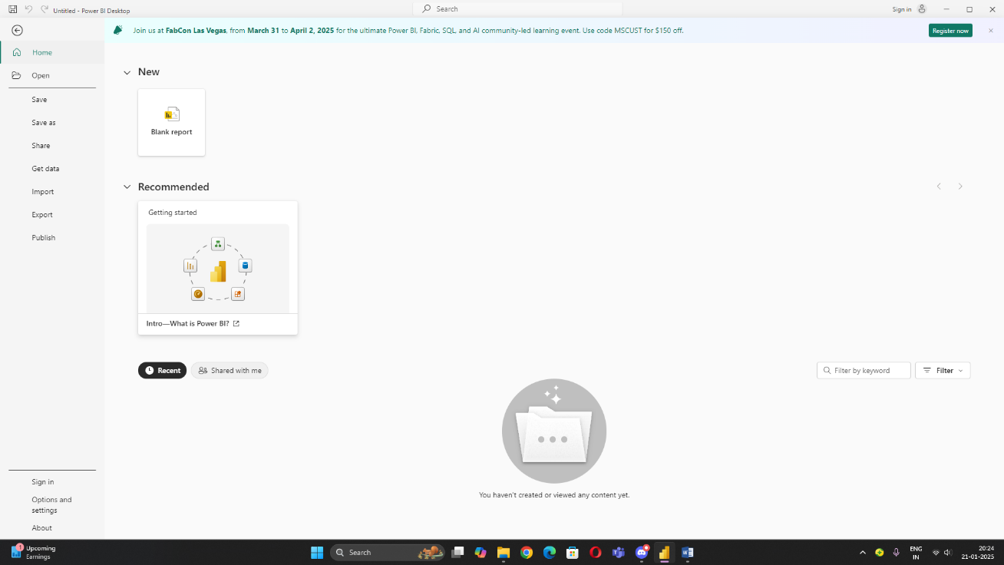

Power BI is a **business analytics tool** developed by **Microsoft** that enables users to visualize, analyse, and share data insights. It is a cloud-based platform that allows organizations and individuals to connect to various data sources, transform and model data, and create interactive dashboards and reports.

**STEP:- 1**

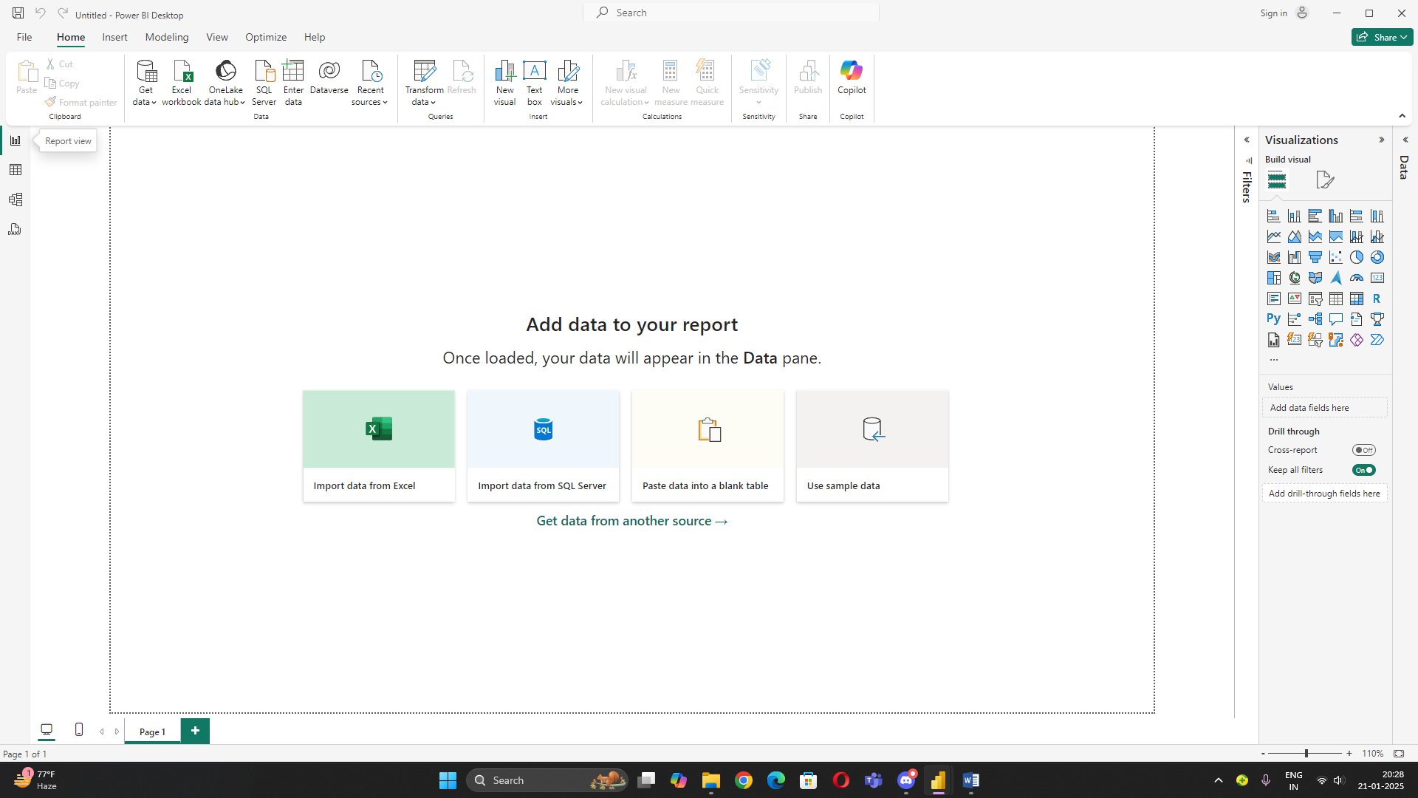

**Choose a csv / excel file**

**STEP:- 2**

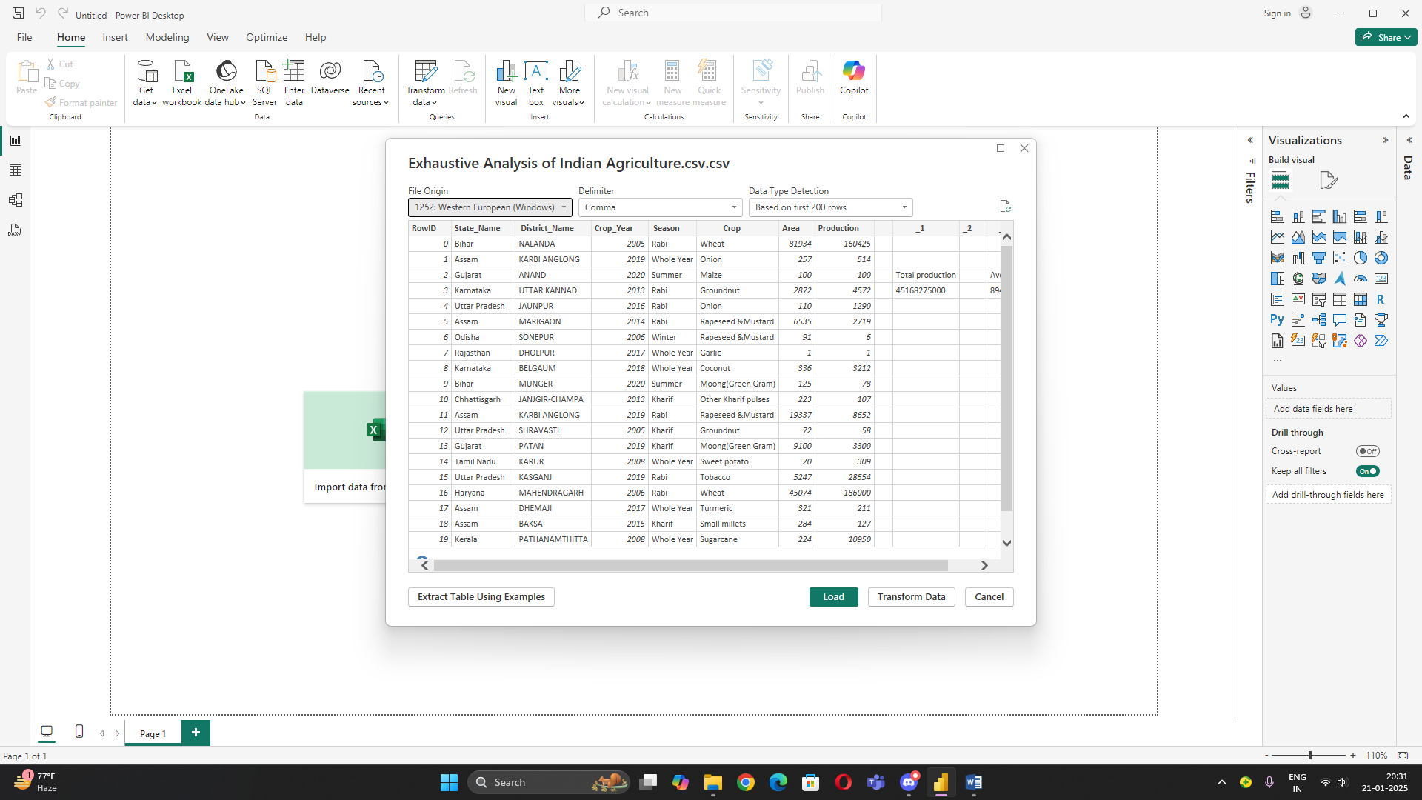

**1. Extract :** Data is fetched from various sources, such as:

**2. Load :** The extracted data is loaded into **Power BI Desktop** or the **Power BI Service**. At this stage, the data remains in its raw form, ready for transformation.

**3. Transform :** Transformations are applied to clean, shape, and prepare the data for analysis.

In Power BI, you can delete unwanted columns and rows during the data preparation stage using **Power Query Editor**.

**Steps to Delete Unwanted Columns:**

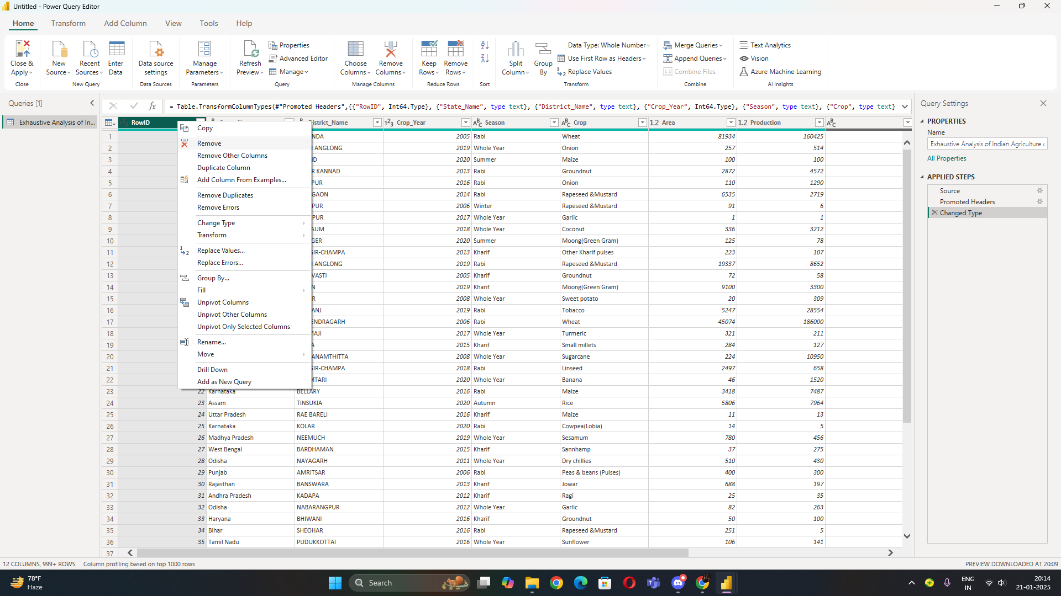

1. **Open Power Query Editor**:
2. In Power BI Desktop, click on **Transform Data** in the ribbon to open the Power Query Editor.
3. Select columns
4. Right-click on the selected columns and choose **Remove**.

**How to remove duplicates:**

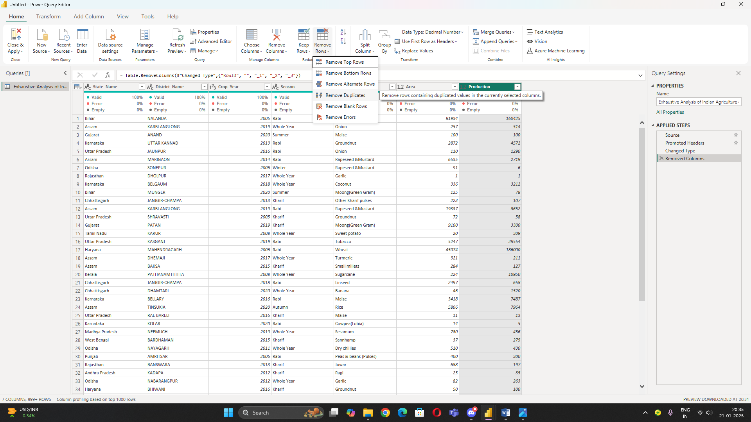

To remove duplicate rows:

1. Select the column(s) that define uniqueness.
2. Click **Remove Duplicates** in the ribbon under the **Home** tab.

In **Power BI**, "views" refer to different areas and perspectives within the Power BI Desktop environment where users can interact with their data, create visualizations, and build reports

1. **Report View**



* **Purpose**: Create and design interactive reports and dashboards.
* **How to Access**: Default view when opening Power BI Desktop (indicated by a report icon 📝 on the left sidebar).

1. **Model View**

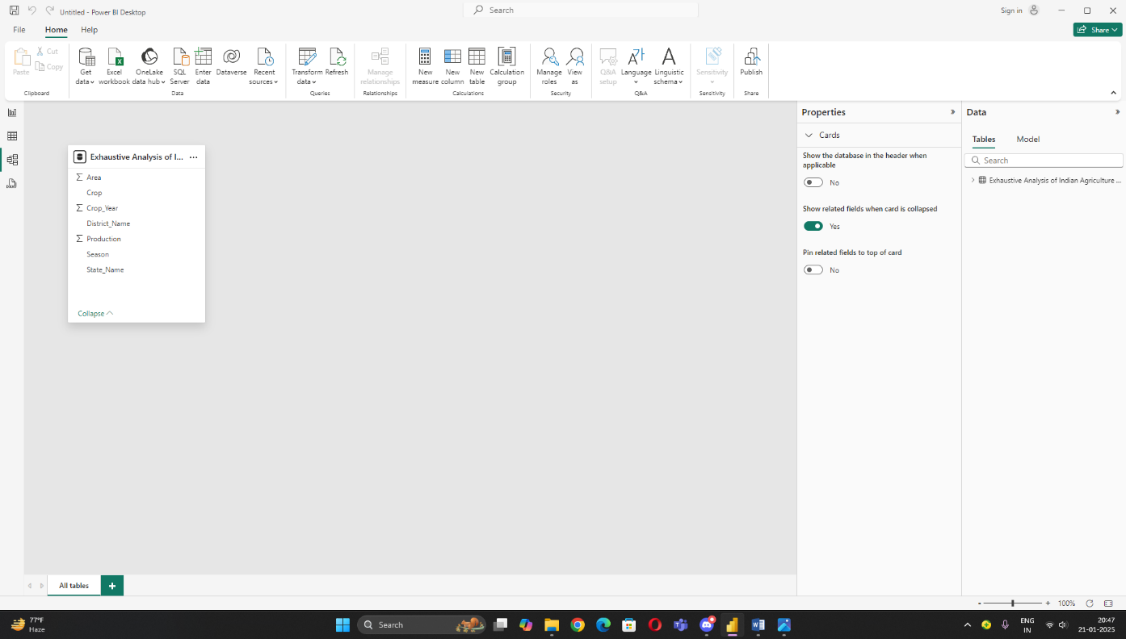

* **Purpose**: Define relationships between tables and set up the data model.
* **How to Access**: Click the model icon (a connected diagram) on the left sidebar.

1. **Table view**

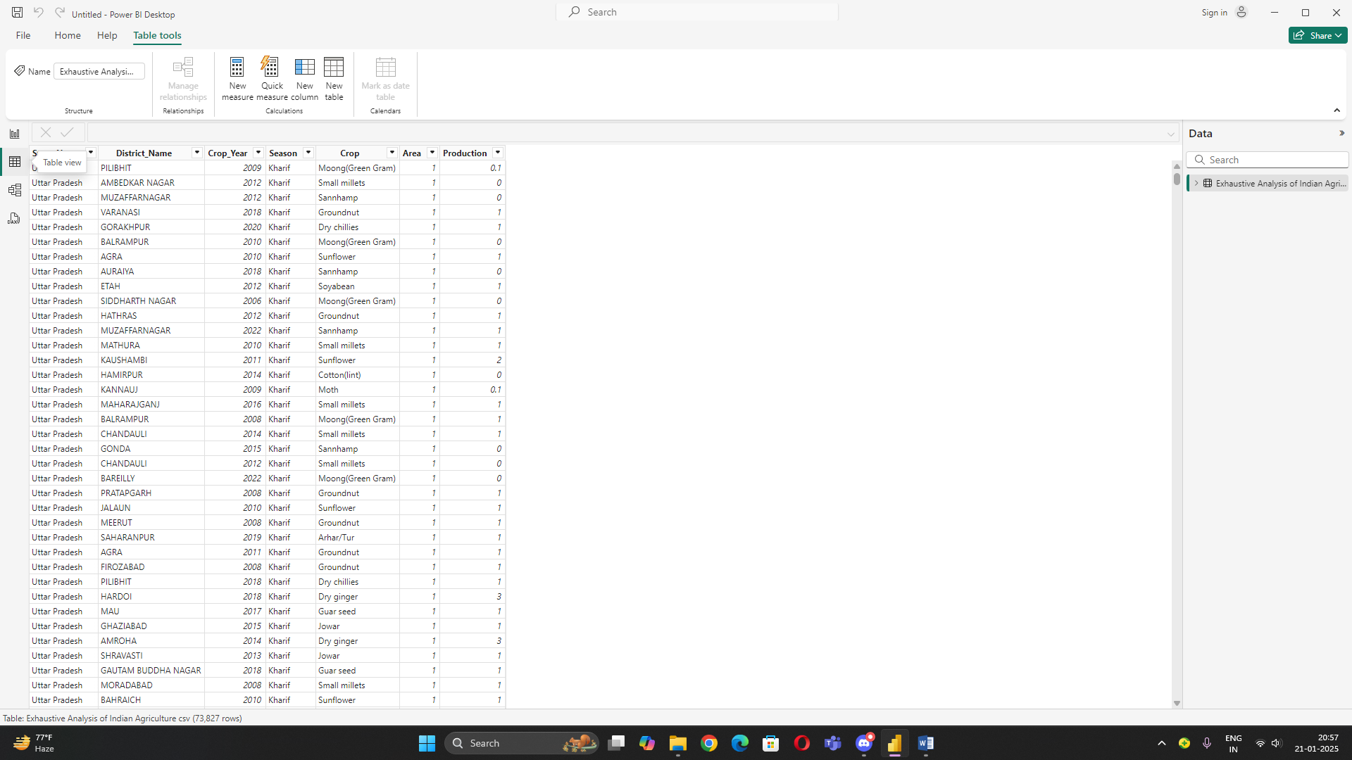

* **Purpose**: Power BI allows you to inspect, validate, and create calculated columns for your data in a tabular format, ensuring your dataset is ready for analysis.
* **How to Access**: Click the **Data View** icon in Power BI Desktop and select a table from the Fields pane to access its data.